Clemson University
Stereo Matching
Assignment 5, ECE 847
Ujwal C Naik
Assignment Number 5

Report for the 5th assignment for Digital Image Processing

Introduction:
Stereo vision refers to the process of recovering 3-Dimensional information about the scene from multiple images of the scene taken at the same time by different cameras. This technique provides additional sensory inputs which allow us to perceive the 3rd dimension which is missing from normal images due to the nature of the imaging process.
The aim of this assignment is to implement correlation based stereo matching algorithm on 2 stereo rectified images of the same scene, and mapping the data obtained in 3 dimensions. The correlation based stereo matching algorithm basically tries to determine for each point in an image the corresponding point in the other image, where two pixels are said to correspond if both pixels are projections along line of sight of the same physical scene element.

Method:
A correlation based approach is used for solving the problem of stereo matching. This method assumes a few constraints which must be followed so as to get reasonable results. They are
- Cheirality: Only points on certain sides of the image plane are visible to the camera.
- Maximum Disparity: This constraint forbids matches whose disparity value exceeds a certain amount.
- Uniqueness Constraint: A pixel in one image can be matched to only one pixel in the other image.
- Ordering constraint: Disparity function is monotonic.
- Epipolar: Points must lie on the same line.
To achieve correlation based stereo we implement Block matching algorithm. It is an area based approach that relies upon statistical correlation between local intensity regions. For each pixel (x,y) in the left image, we search for the best possible match in the right image among all possible disparities.
Similarly, we can perform the block match algorithm on the right image. Ideally, both answers should agree with each other but in practice the pixels don’t always agree with each other due to reasons such as occlusions, specular reflections, etc. This is remedied by performing the Left-Right Disparity Check. First the left image is used as reference and a disparity map is created then we do the same with the right image as reference. Wherever the pixels of both the images agree with each other the disparity value is retained, wherever the two reference images disagree with each other the disparity value is discarded.
The various steps in the algorithm are as follows:
- Setting disparity value: Load the left and the right image and set the maximum and minimum disparity values.
- Computing Dissimilarity Measures: We need to calculate the dissimilarities in the corresponding left and right images for all the disparity values. Thus for each value of disparity we create a dissimilarity image.
- Creating a 3-Dimensional Data Structure: We create a 3-dimensional data structure to store the dissimilarity values for different disparities. This data structure is an array of images storing dissimilarities for different disparities. Convolve each dissimilarity image with a box of 5x5.
- Calculate the left and right disparity maps: Using the 3-Dimensional data structure generated in the last step, for each pixel (x,y) we select the disparity value for which the dissimilarity is minimum, first with the left image as reference and then with the right image as a reference.
- Left-Right Consistency Check: For every pixel if the disparity value of the left disparity image is equal to the disparity value of the corresponding right disparity image then the disparity value at that pixel is retained otherwise the pixel disparity value is discarded.
- Generating a .ply file: Generate a .ply file that contains information of the x,y,z co-ordinates and the color channel information. This mesh file when opened in Meshlab produces 3 dimensional results.

Algorithm:
The algorithm stereo matching can be explained as follows:
- Load left and right images and maximum disparity value.
- Calculate dissimilarity values for all values of disparities.
- Store the images with dissimilarity values for all values of disparities in an array. This forms a 3 dimensional data structure.
- Create disparity maps first with reference to the left image and then with reference to the right image. Using the 3 dimensional data structure – for every pixel choose the value of disparity for which the value of dissimilarity is minimum
- Perform Left-Right consistency check.
- Calculate all the information required for generating a 3d representation in Meshlab and store these values in a .ply file.

RESULTS

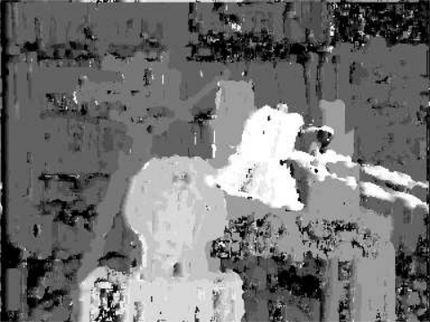
Left Disparity Map

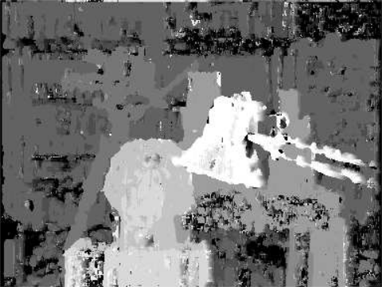
Right Disparity Map

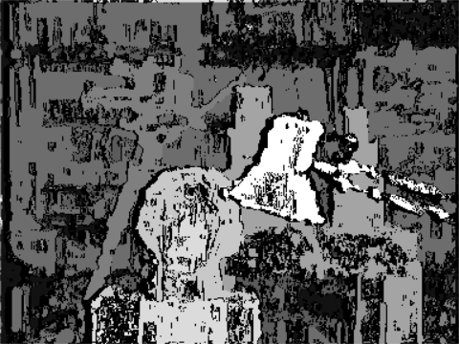
Left-Right Disparity Check

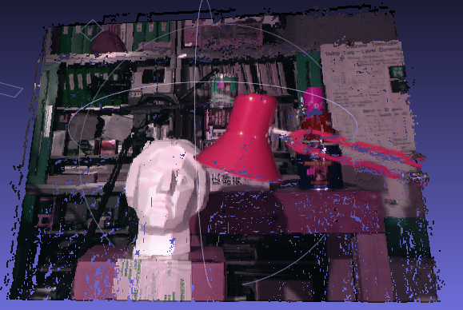

Meshlab Output

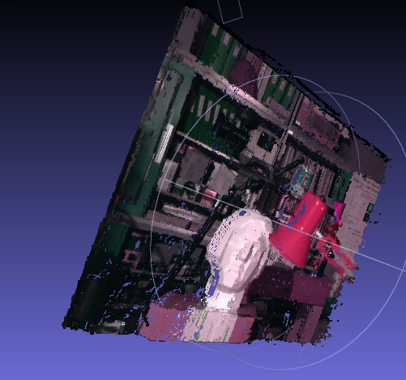

Meshlab Output

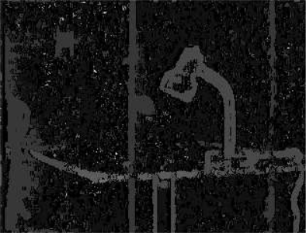
Left Disparity Map

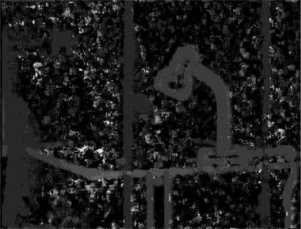
Right Disparity Map

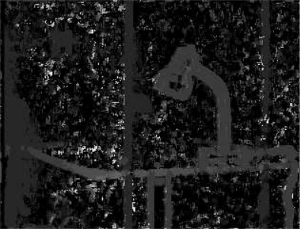
Left-Right Consistency Check

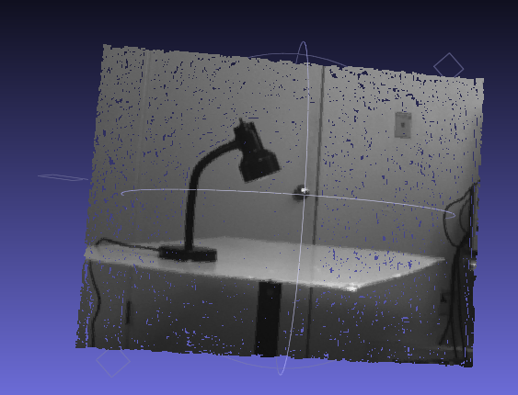
MeshLab Result.

Conclusion
The stereo matching algorithm that has been implemented works satisfactorily for all inputs.
There are various factors that affect the performance of the stereo matching algorithm. The algorithm doesn’t perform well for all sets of images as seen in the results section for the second set of images.
In the link provided in the assignment we can see none of the algorithms are capable of giving a result that is free of error even on test images which have been cleaned of noise and have all requirements met. This gives us an appreciation of exactly how complex and difficult the problem of stereo vision actually is.

